

Performance Test Strategy

UPS IVIS NG Project
Version 0.3

Control History

Revision History:
S No | Date | Ver. # | Author | Section / Page # changed | Details of changes made
1 | 12/12/16 | 0.1 | Pragati Rai
2 | 12/13/16 | 0.2 | Pragati Rai
3 | 12/14/16 | 0.3 | Pragati Rai

Review By:
Name | Date | Area

Table of Contents
1Introduction 5
1.2.1Project Scope 5
1.2.1.1Early Performance Test 6
1.2.1.2End to End Performance Test 6
1.5.1Assumptions 6
1.5.2Risk 7
2Requirement 7
1.6.1Single User Testing 7
1.6.2Load Test 7
1.6.3Endurance Test 7
1.6.4Failover Testing 7
1.6.5Scalability Testing 8
1.10.1Throughput 10
1.10.2Response Time 11
1.10.3Resource utilization 11
1.12.1Single User Test 14
1.12.1.1Need & Benefits for Testing 14
1.12.1.2Objective 14
1.12.1.3Entry Criteria 14
1.12.1.4Activities 14
1.12.1.5Exit Criteria 14
1.12.2Load Test 15
1.12.2.1Need & benefits of Testing 15
1.12.2.2Objective 15
1.12.2.3Entry Criteria 15
1.12.2.4Activities 15
1.12.2.5Exit Criteria 15
1.12.3Endurance Test 15
1.12.3.1Need & benefits of Testing 15
1.12.3.2Objective 16
1.12.3.3Entry Criteria 16
1.12.3.4Activities 16
1.12.3.5Exit Criteria 16
1.12.4Failover Testing 16
1.12.4.1Need & benefits of Testing 16
1.12.4.2Objective 16
1.12.4.3Entry Criteria 17
1.12.4.4Activities 17
1.12.4.5Exit Criteria 17
1.12.5Scalability Testing 17
1.12.5.1Need & benefits of Testing 17
1.12.5.2Objective 17
1.12.5.3Entry Criteria 17
1.12.5.4Activities 17
1.12.5.5Exit Criteria 17
3Appendix A 21

Introduction
The purpose of this document is to define the Performance Test Strategy and Approach for UPS IVIS NG application. It describes the methods and tools used by the Performance Team to validate the Performance of Mobile communication layer and the UPS IVIS NG mobile application.

This strategy document shall also include the testing requirements that must be satisfied by conducting a Performance Test to ensure that the Performance requirements have been met.

Purpose
This Test Strategy is created based on the following objectives,

Objective I: Verify that performance parameters specified In NFR
The application will be tested for anticipated user load and check their performance against given SLA targets (response time, projected transaction volumes, concurrent users etc.)

Objective II: Identify performance bottle-necks
The application will be tested to identify any performance issues arising out of infrastructural or application design.

Objective III: Verify failover scenarios
Application failover –abrupt and graceful- will be executed to verify the that the application supports failover

Scope

Project Scope

This section tells about the scope of the performance testing. The non-functional requirements with respect to performance for IVIS next generation application (mobile app) will be tested during this phase using HP Load Runner. Performance testing will be conducted in integrated production like test environment. Early performance testing (single user testing) will be conducted at the end of each sprint validating the non-functional requirements for the user stories accepted within the sprint along with the MQTT components involved. End to End performance testing will be conducted during the last Sprint and extended into Alpha Test. The following activities will be carried out during the sprints.

- Performance test scenarios will be derived from the nonfunctional requirements during the sprint
- Performance test scenarios/ test cases to be uploaded in HP ALM
- Conduct early performance testing for the sprint’s final build
- Conduct end to end performance testing after the last Sprint for the final build
- Execution status to be updated in HP ALM
- Defects to be captured in TFS

Test Phase | Entry Criteria | Exit Criteria
Performance Testing | 1. Test environment for performance testing  2. Sample message /web url to be available for the identified scenarios  3. Tools installed and connectivity established – (HP load runner) | 1. 100% performance test scenario execution  2. Implementation of the recommendations to remove performance bottlenecks

Below tests will be covered as a part of early and end to end performance testing.

Early Performance Test
- Single User Testing : Single user testing will be done for all services and MQTT implementation which is ready in every script at the end of every sprint cycle.
- This can be done using in HP Performance Center by iterating the scripts ( service and MQTT) for 10 minute duration Simulation of Wi-Fi 802.11b /g networks and 4G( band 3,7 or 20 ) networks with custom settings
- Comparison reports can be obtain after every iteration and analysis can be done every stage to eliminate early performance issues.
- Early performance testing can be only done after the complete implementation of the intended service /MQTT messages

End to End Performance Test
- Load test
- Endurance test
- Fail over test
- Scalability Testing

Out of Scope
This section tells about what is not in scope for the performance testing of UPS IVIS NG

- Apart from the performance test types mentioned in In-Scope is considered to be out of scope
- Preparing the test environment for performance testing
- Tuning the application by the performance testing team

Acronym & Definition
This section contains information about all acronyms that you will be using inside the document.
For example:
LT Load Test
SUT System under Test
VU Virtual User
SLA Service Level Agreement
PT Performance Testing
LR Load Runner
TFS Defects reporting tool

Assumptions & Risk

Assumptions
Following are the assumptions made while preparing the strategy for performance testing UPS IVIS NG application,
- Requirements ( Non Functional Requirements ) for performance testing will be provided with the sign off from stake holders
- Functionally stable build is available for performance testing
- Dedicated production like environment is available for performance testing
- Sprint tasks are planned well in advance
- Performance testing tools are available and feasible with the applications
- Test data should be readily available
- Support from development, DBA and Infra structure teams are available for monitoring the servers and analyzing performance requirements and results.
- Dummy messages with existing schema will be used for load generation

Risk
Following are the risks which can hamper the smooth execution of the tests,
- Unavailable or delay with the required documents/information
- Unavailable or delay with the administration support (Application server and Database)
- Delay in preparing the test environment, test data including the database etc.,
- Ad-hoc requests out of the approved plan

Requirement
Performance testing for UPS IVIS NG application is based on the following list of requirements,

Types of test

The following Performance test types are executed during the Performance Testing of UPS IVIS NG application.

Single User Testing
Each business process will be executed individually without any concurrent requests/users. Requests/messages will be posted sequentially. This test will be conducted as a part of early performance testing and hence will provide the optimum performance of the system. This will not be taken as the baseline test for the application. We will have a baseline after the end of all functionality in place.

Load Test
Load test emulates the production scenario by generating the load with right transaction mix and right load on the server at any point of time. All business processes are tested together for full load.
This test will provide the performance metric and application state in case of live like load.

Endurance Test
A load test that is run for an extended period of time, considering 8 hours for IVIS NG with the purpose of detecting slow-to-appear defects. This measures the reliability of the system. (Data, system availability, isolated testing)
This test will help in identifying the application behavior under load for longer period of time

Failover Testing
Failover testing is a testing technique that validates a system's ability to move operations to back-up systems during the application failure due to one or the other reasons.
This determines how system is capable of handling the planned or unplanned outages in terms of recovery time, data loss etc.
Systems considered for Failover scenario:
- TSIS ( Server: , Instance: )
- HFCS ( Server: , Instance: )
- IVIS ( Server: , Instance: )

Scalability Testing
Scalability Testing is the testing of a software application to measure its capability to scale up or scale out in terms of any of its non-functional capability.
The system shall be scalable to support an employee base of 18,300
The system shall be scalable to support an employee base of 25,000 (20000) during peak
The system shall support maximum number of concurrent user base of 2000
The system must have the following bandwidth for future growth: 2% to 5% growth for 1 year

In Scope Business Processes
This section contains information about the list of business processes which has been identified for performance testing of the IVIS NG application. The information can be captured by considering most occurring scenario for each business process derived from all available functionality. Application will be performance tested for both web service and Messaging (MQTT) scenarios.

    - Web Services Scenarios

Actor | Functionality
Feeder Driver | Login/Punch-in
Feeder Driver | Logout
Feeder Driver | Punch-out
Active Driver on Sleeper Job | Login/Punch-in
Inactive Driver on Sleeper Job | Login/Punch-in
Active Driver on Sleeper Job | Logout
Inactive Driver on Sleeper Job | Logout
Active Driver on Sleeper Job | Punch-out
Inactive Driver on Sleeper Job | Punch-out

    - MQTT Scenarios

Actor | Functionality
Feeder Driver | On Property Activities  Break/Meal/Fuel
Feeder Driver | Pair Tractor
Feeder Driver | Schedule Edit
Feeder Driver | Outbound Load
Feeder Driver | Outbound Equipment
Feeder Driver | Leave
Feeder Driver | Pickup
Feeder Driver | Delivery
Feeder Driver | Leave
Feeder Driver | Inbound (TA)
Feeder Driver | On Road Activities  Traffic Delay/Accident
Active Driver on Sleeper Job | Outbound Load
Active Driver on Sleeper Job | Outbound Equipment
Active Driver on Sleeper Job | Leave
Active Driver on Sleeper Job | Inbound (TA)
Active Driver on Sleeper Job | Inbound Load
Active Driver on Sleeper Job | Inbound Equipment
Active Driver on Sleeper Job | On Road Activities  Traffic Delay/Accident/Fuel/Weather Delay/Drug Test
Active Driver on Sleeper Job | On Property Activities  Off Site Driving  Breakdown  Build Set  Change Tractor  Held By CustomerOn Property Activities  Off Site Driving  Breakdown  Build Set  Change Tractor  Held By Customer
Active Driver on Sleeper Job | Berth
Inactive Driver on Sleeper Job | Switch User
Inactive Driver on Sleeper Job | Off Duty
Inactive Driver on Sleeper Job | On Duty Not Driving
Inactive Driver on Sleeper Job | Break/Meal

User Division
This section contains information about the different types of users accessing the system. IVIS NG application will be accessed by two types of users

Sr. No | User Types | Percentage of Logged in Users
1 | Feeder Driver | 18000
2 | Sleeper Driver | 300

4 PM to 2 AM maximum number of users – 8000 to 10000

Expected No Of Users
IVISNG application should be able to support 2000 concurrent users. Division of users for respective driver is as below
For example:

Types of Users | Total Registered Users | Average Concurrent Users | Maximum Concurrent Users
Feeder driver | 18000 | 1000 | 2000
Sleeper driver | 1000 | 100 | 200
Total Users | 19000 | 1100 | 2200

Performance Targets

Throughput
This section contains the overview about the throughout requirement of IVIS NG application
- The system must be able to support 32 of user generated web service calls per second. Each service has defined limits that would control the number of threads that would throttle throughput.
- The system must be able to accept 5000 message per minute inbound to IVIS NG communications layer message server

Response Time
This section contains the response time targets for the Business Processes which are identified for performance testing.
Interfaces and Extracts | Wi-Fi |  | Cellular
Interfaces and Extracts | Best Case | Worst Case | Best Case |  | Worst Case
Arrival – IVIS-NG Mobile Device to Data Brokering Server (TSIS) | ≤1 sec | 5 sec | ≤1 sec |  | 5 sec
Departure – IVIS-NG Mobile Device to Data Brokering Server (TSIS) | ≤1 sec | 5 sec | ≤1 sec |  | 5 sec
Send GPS Data – IVIS-NG Mobile Device to IVIS | ≤3 sec | 5 sec | ≤3 sec |  | 5 sec
Inventory Control – IVIS-NG Mobile Device to IVIS | ≤3 sec | 5 sec | ≤10 min |  | 20 min
Schedule Update – IVIS to IVIS-NG Mobile Device | ≤5 sec | 10 sec | ≤5 sec |  | 10 sec
Beginning of Day (Punch-in / Log on) – IVIS to IVIS-NG Mobile Device | ≤30 sec | 40 sec | ≤30 sec |  | 40 sec
Ack Text Message – IVIS-NG Mobile Device to IVIS | ≤1 sec | 5 sec | ≤5 sec |  | 10 sec
Ack Text Message – IVIS to IVIS-NG Mobile Device | ≤1 sec | 5 sec | ≤5 sec |  | 10 sec
Ack Text Message – IVIS-NG Mobile Device to ShiftCom | ≤1 sec | 5 sec | ≤1 sec |  | 5 sec
Ack Text Message – ShiftCom to IVIS-NG Mobile Device | ≤1 sec | 5 sec | ≤1 sec |  | 5 sec
Shift Assignment Message – ShiftCom to IVIS-NG Mobile Device | ≤1 sec | 5 sec | ≤1 sec |  | 5 sec
Broadcast Text Message – IVIS to IVIS-NG Mobile Device | ≤30 sec | 40 sec | ≤30 sec |  | 40 sec
Text Message – IVIS-NG Mobile Device to IVIS | ≤30 sec | 40 sec | ≤30 sec |  | 40 sec
Text Message – IVIS to IVIS-NG Mobile Device | ≤30 sec | 40 sec | ≤30 sec |  | 40 sec
Text Message – IVIS-NG Mobile Device to ShiftCom | ≤10 sec | 15 sec | ≤10 sec |  | 15 sec
Text Message – ShiftCom to IVIS-NG Mobile Device | ≤10 sec | 15 sec | ≤10 sec |  | 15 sec
End of Day (Punch-Out / Log Off) – IVIS-NG Mobile Device to IVIS | ≤15 sec | 1 min | ≤15 sec |  | 1 min

Resource utilization
This section contains the CPU and memory utilization targets for different servers that serve the application under performance test.
- The communication layer services should be designed such that communication layer servers’ utilization (defined by CPM) does not exceed 40% under normal operating conditions (no component failures) and 80% under a failure condition : Load and failure mode of communication layer
- The system should be designed such that mobile device CPU / memory / storage utilization does not exceed 90% under normal operating conditions (no component failures) Note: certain ‘normal’ operations on the device will exceed this and max CPU out on the device for a brief span of time: load test checks.

Performance Test Strategy
- The Test Strategy presents the recommended approach to testing the UPS IVIS NG mobile application. The previous section on Test Requirements described what would be tested; this section describes how it will be tested.
- The main considerations for the test strategy are the techniques to be used and the criterion for knowing when the testing is completed.
- In addition to the considerations provided for each test below, testing should only be executed using known, controlled databases, in secured environments.

Test Approach
TCS has come up with a tailored approach for executing the Performance Testing.
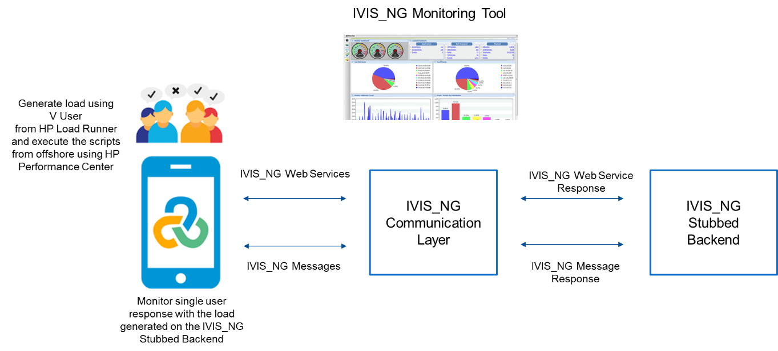

Proposed Performance Test Approach

Phases | Entry | Task | Validation | Exit
Requirement Analysis & Test Plan | - Detailed system study of applications  - Understanding environment  - Requirements and workload analysis documents | - Prepare test strategy, risk and mitigation plan  - Define test objective, scope, testing phase, activities and responsibilities | - Review Test strategy  - Review risk and mitigation plan | - Signed off test strategy  - Booked test environment based on performance test schedule
Test Design | - Test strategy  - Test environment and tool set up  - Test data identification | - Setup/Validate test environment  - Develop test scripts and scenarios  - Validate test environment including application, test data, monitoring | - Review the test script to ensure correct load simulation  - Review test scenarios  - Review test execution plan | - Signed off test scripts and test scenarios  - Completion of test environment access and configuration pre-requisites
Test Execution | - Signed off test scripts and test scenarios  - Test execution plan  - Availability of test environment  - Functionality stable application  - Test results of all the different scenarios | - Execute the test cases for the planned test cycles  - Collate test execution results  - Rerun test if required | - Review the collated test results  - Review test summary report  - Review the detailed test report with recommendations  - Review the status of test progress versus plan | - Signed off test summary report  - Signed off detailed test report with recommendations
Reports | - Test results of all the different scenarios | - Prepare test summary report  - Provide detailed test report with recommendations  - Verify that performance targets are met. | - Validate whether the test results are meeting the SLA criteria  - Identification of bottlenecks | - Test summary report  - Final consolidation report  - Test results sign off

Performance Testing is focused on measuring,
- Response time of application’s key business transactions on real devices
- Impact of network conditions on the user experience
- Performance of the application under realistic load conditions

Test scripts are scripted manually using C VUser generator. We would modify the test scripts as per the required scenario. Sanity Successful test scripts would be used in the performance center for Performance Test Execution.

The detailed step- by –step Test Approach process is as below

Step1: Requirement Gathering
- Identify the list of business transactions in scope for performance testing by:
  - Gathering inputs from business users
  - Analyzing the production log
- Finalize the transaction mix and user load
- Discuss with the stake holders to define the performance SLAs

Step2: Design
- Setup the performance testing environment for the stubbed communication layer and web service request
- Develop the performance test scripts for the identified business flows
- Setup the data similar to production volume required for the performance test

Step3: Execution

Single User Test
Each business process will be executed individually without any concurrent requests/users. Requests/messages will be posted sequentially.

Need & Benefits for Testing
Need for baseline testing are as follows,
- Test environment (Gold/Copper) does not have the capability to handle the full load of IVIS NG application. Baseline tests does not generate load on and helps validate the response times in optimal scenarios.
- If response time of business process is greater than given SLA in baseline, defects can be raised at this stage making way for early performance tuning wherever required.
- Benefits - 85% of performance problems can be identified and solved when proper baseline tests are done.

Objective
Objective of this testing is to:-
- Identify optimal performance of E2E business process connected to back-ends without any load.
- Validate optimal performance of E2E business process against the agreed SLA.
- Finding out the performance bottle necks in early stage of lifecycle.

Entry Criteria
- Functional and regression testing has to be completed for the business processes under test.
- Environment with E2E connectivity available.
- Latest build should be available with no showstopper functional open defects
- Necessary data setup completed to perform the test
- Load runner script prepared for business process under test.

Activities
- This is only test phase which will be executed in test environment (i.e. not in prod like environment)
- Single User test execution for all in scope business for 15 minutes
- Produce results on E2E response times and breakdown on where the time is spent( with the help of load runner and other monitoring tool)
- Collect the server logs and metrics
- Defects raised for processes not meeting the SLA in TFS.
- Monitor the systems layer wise to analyze more on the backend systems

Exit Criteria
- Complete the baseline test for all process in scope.
- Discuss with business team for the processes with defects to revisit them in order to achieve the agreed SLA

Load Test
Load test emulates the production scenario by generating the load with right transaction mix and right load on the server at any point of time. All business processes are tested together for full load.

Need & benefits of Testing
Need for load testing are as follows-
- Prove the new IVIS NG application is able to sustain live like load requirements.
- Prove the IVIS NG application business processes meet performance requirements when the system is subjected to load test.
- Benefits – finding the system throughput, hardware issues in the servers and application related issues during normal and peak load conditions

Objective
Objective of this testing is to:-
- Validate whether IVIS NG application meets the E2E performance requirements when the system is subjected to near live like load.

Entry Criteria
- Production like environment availability to be ensured.
- LR scripts updated with all latest changes as per the sprint
- Baseline test completed for all in-scope business processes
- Additional data set up should be completed for the required amount and types of data pertaining to all business processes.

Activities
- This test will be executed in production like environment
- Executing E2E load test for 1 hour duration
- Produce results on E2E response times and breakdown on where the time is spent( with the help of load runner and other monitoring tool)
- Collect the server logs and metrics
- Defects raised for processes not meeting the SLA in TFS

Exit Criteria
- Complete the load test for the live like load.
- Discuss with business team for the processes with defects to revisit them in order to achieve the agreed SLA
- Identify bottlenecks and provide recommendations for the same.

Endurance Test
A load test that is run for an extended 8 hours of time, with the purpose of detecting slow-to-appear defects. This measures the reliability of the system.

Need & benefits of Testing
- To prove that system availability for longer period of time without any failure
- To prove system performance when load is subjected for longer duration
- Benefits – Able to identify Memory leaks

Objective
Objective of this testing is to:-
- The objective of the Endurance test is to find how the system behaves under sustained use.
- Endurance test will be running in the system for extended period of time with significant users and thereby to check if there any memory leaks and garbage collection issues.
- To validate system /resource performance during and after the test
- To ensure that system performance is acceptable under given load for prolonged periods of usage

Entry Criteria
- Load test completed successfully i.e. environment able to handle the load for 2 hours
- Necessary data setup completed to perform the test
- Load runner script prepared for business process under test.

Activities
- This test will be executed in production like environment
- Endurance test will be executed for 8 hours duration
- Produce results on E2E response times and breakdown on where the time is spent( with the help of load runner and other monitoring tool)
- Produce the results for memory usage and CPU usage for the duration of test
- Collect the server logs and metrics
- Defects raised for processes not meeting the SLA in TFS

Exit Criteria
- Complete the endurance test for the required duration
- Discuss with business team for the processes with defects to revisit them in order to achieve the agreed SLA
- Identify bottlenecks and provide recommendations for the same.

Failover Testing
Failover testing is a testing technique that validates a system's ability to be able to allocate extra resource and to move operations to back-up systems during the server failure due to one or the other reasons. This determines if a system is capable of handling extra resource such as additional CPU or servers during critical failures or at the point the system reaches a performance threshold.

Need & benefits of Testing
- To ensures that the systems can successfully failover and recover from a variety of hardware, Software or network malfunctions with undue loss of data or data integrity.
- Benefits – Able to identify message or data loss
- Ensuring the recovery system performs as good as planned.

Objective
Objective of this testing is to:-
- The key objectives will be to simulate hard and soft failover to insure that the system will be able to process user traffic in diminished modes. The failover will be executed for the components as per the details agreed in NFR
- To ensure that system performance is acceptable under the given failover scenario
- Individual component failures can be find out.

Entry Criteria
- Slot is available and failure events to be created is discussed and agreed.
- Test plan has been completed and the respective stakeholders have reviewed the same and signed off
- In case of Failover testing for impacted application/component, the corresponding Application team (SPOC) is aware of the dates and failure events to be tested by them.( Need the details )
- Supporting team has been informed and resources have been allocated to support Fail over testing
- Test data and environment are ready.

Activities
- Walk through for test cases and confirm that the failure vents are feasible
- Execute the test and bring down either of the server instance and validate the further requests are hitting other up & running server instance
- Raise and track the defects in TFS in case of any issues
- Share test reports with stakeholders.

Exit Criteria
- Share the results with the stakeholders and provide recommendations if any

Scalability Testing
Scalability Testing, is the testing of a software application to measure its capability to scale up or scale out in terms of any of its non-functional capability.

Need & benefits of Testing
- To ensure that application supports the future growth in terms of users etc.

Objective
Objective of this testing is to:-
- To validate the system behavior and performance in case of future growth

Entry Criteria
- Test scenario to be created as per the growth estimation
- Environment availability to handle the required load
- Test data availability

Activities
- Execute the test as per the scenario
- Raise and track the defects in TFS in case of any issues
- Share test reports with stakeholders.

Exit Criteria
- Share the results with the stakeholders and provide recommendations if any
- Collect the performance metrics and analyze the results against all type of performance tests
- Identify the application level performance bottle necks using the APM tool App Dynamics reports
- Report the performance defects and performance issue if any and get it fixed and re-test
- Prepare the final performance test report with recommendation and suggestions
- Publish the report and get sign-off from all the stake holders
- Validate the ETVX methodology in the Reporting phase

Step4: Reporting
- Prepare test summary report
- Provide detailed test report with recommendations
- Verifying and Validating whether the test results are meeting the SLA criteria
- Identification of bottlenecks
- Final consolidation report with all performance metrics taken into consideration.
- Test results sign off

Test completion criteria
- The results must be collected during the scenario execution and validated the results that no performance issues in the execution.
- The consistency of the results is confirmed by executing the scenario multiple times etc.,
- The response time for all transactions should be as per the SLA

Monitoring Strategy
Following are the performance counters monitored during the performance test using the monitoring tool available,
- Response Time
- Throughput
- CPU usage graph [ All the servers involved ]
- Memory usage graph [All the severs involved ]
- GC Logs (On required servers)
- Heap usage and JVM activities [if configured]
The detailed list of counters will be identified for each component within the system/application and will be setup appropriately in the monitoring tool. TCS Performance testing team will collaborate with infrastructure team, Architects team and Business team for defining the monitoring strategy (What to monitor and frequency of measurement).

Some of the counters that will be monitored as a part of the execution are listed below: Need to know about the tools which will capture below metric

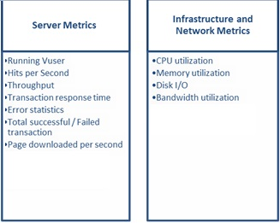

Tools
- Performance Testing Tool: HP Load Runner 12.53
- Monitoring Tool: Inbuilt tool [ if present] / Dynatrace/AppDynamics/ CA Introscope
- Integration : HP Load Runner Integrated with HP ALM
- TFS: Defect recording tool

Integration of HP Load Runner with HP ALM
We could integrate the Controller and Analysis components of HP Load runner to HP Quality Center. We can perform the below activities once HP-Load runner Controller component is integrated with HP QC,
- Creating the Performance Test Scenario
- Running the Performance Test
- Viewing and Analyzing the test results
- logging the defects for the test in case any we found any defects

We can open test results on HP-LR Analysis Component from HP ALM. Also we have provision to modify the reports with proper description and save it in ALM.

We have to validate the compatibility of HP Load Runner and HP ALM before integration.

We will be recording the scripts from HP-LR VuGen Component. We will modify the scripts for successful replay of scripts. Successfully replayed scripts would be taken to the HP-LR Controller Component for performing the various sort of Performance Tests.

The below mentioned steps are followed for integrating HP Load Runner with HP ALM,
- Create a new test in Test Lab of HP ALM and Type as “LR-SCENARIO”. Provide Authentication if it asks for creating Test.
- Click the Launch button under ‘Test Script’ tab in HP ALM to open HP-LR Controller.
- Controller will get opened. In the opened Controller screen, we have to design the Performance Test scenario. Design a scenario and click save button to get saved in ALM database.
- Create a ‘Test Set’ in test lab by assigning the ‘test’ from Test plan. I.e. Mapping
- Configure the IP addresses of Load generator. Then click Run.
- Performance Test Scenario would be running in controller – initiated from HP ALM “Test Lab”.
- Once the Run is over, we can start the LR-Analysis.
- Open the ‘Test Instance Properties’ window by double clicking our Test in Test Lab. Click “LR Analysis” button to open LR Analyzer. LR-Analysis window would be opened.
- We can modify the report details in Analysis screen and if we click save button, then it will get stored in ALM DB. Provide Authentication if it asks.
- Now report is available under HP ALM DB for the executed Performance Test and it can be referred any time from HP ALM.

Roles and Responsibilities
S No. | Phase | Activity | Responsibility
 | Requirement Gathering | Gather the performance test requirements | TCS – UPS
 | Planning | Finalize Performance requirements | TCS – UPS
 | Planning | Prepare the performance test plan | TCS
 | Design | Create performance test scripts using Load Runner | TCS
 | Design | Setup the Environment for Performance testing. | UPS - TCS
 | Design | Test data creation | TCS
 | Execution | Execute the performance tests | TCS
 | Execution | Monitoring servers during performance test | TCS
 | Reporting | Analyze the Results and Create test report | TCS – UPS

System
- System architecture diagram of the application needs to be tested
- Configurations of the App/Web/DB Servers in testing environment
- Configurations of the App/Web/DB Servers in production environment
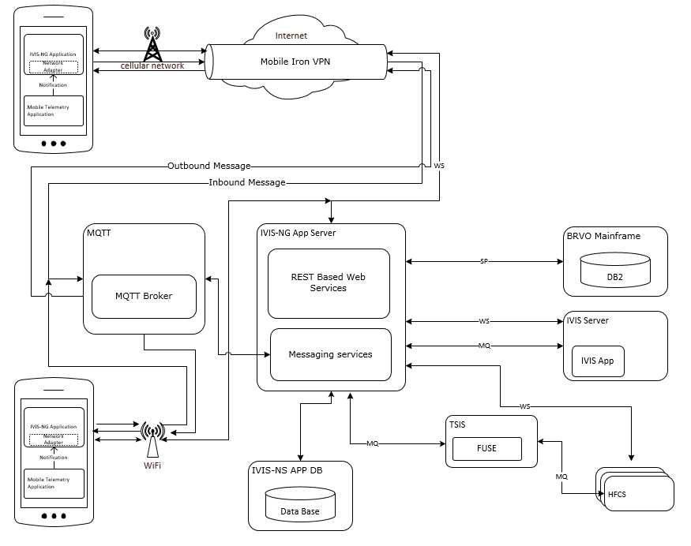
UPS IVIS NG Application Architecture

Deliverables
S. No | Deliverable Name | Description
 | Test Strategy | Describes the high level strategy
 | Performance Requirements | Document contains the Performance targets and workloads that system should be verified against
 | Test Plan | Describes the detailed plan
 | Performance test scripts | Performance test scripts created using chosen performance testing tool
 | Performance Results | Report showing the performance of UPS IVIS NG application, application server, Database server
 | Test Completion Report (Final) | Document giving test results and findings

Appendix A

Performance Test Terminologies
Terminology | Description
Bottleneck | A bottleneck is a point in an application where congestion and delay occur, slowing down the processing of requests and causing users to experience unacceptable service delays.
Concurrent users | The number of application users actively using and accessing the HGV Application at a particular point of time.
Hits | The number of HTTP requests made by virtual users to the web server
Latency | Delay experienced in network transmissions as network packets traverse the network infrastructure.
Percentile | A percentile is a value on a scale of one hundred that indicates the percent of a distribution that is equal to or below it
Ramp-up Rate | The rate at which the number of users start loading to the system
Response time | Amount of time the application takes to respond to a user request, as experienced by the end user. Response time is an aggregate of time incurred by all server processing and transmission latency for an operation. Response time is based on processing related to the request and to processing for other requests that may affect this user request.
Scenario | A scenario defines the events that occur during each testing session. For example, a scenario defines and controls the number of users to emulate, the actions that they perform, and the machines on which they run their emulations
Think time | The wait time between the response received from the server and the next request sent to the server is known as think time. Average think time is a critical element in performance and scalability testing & tuning. When think time values are correctly forecasted, then actual load levels will be close to anticipated loads.
Throughput | Typically expressed in transactions per second (TPS), expresses how many operations or transactions can be processed in a set amount of time.
Transaction/Test | A transaction represents an action or a set of actions used to measure the performance of the server
Transaction Mix | Varying execution frequency of different transactions
VUser | VUser or virtual users are used by load generating tool as a replacement for human users

